Brantford & District Labour Council
Presents

Annual Soap Box Derby

SEPTEMBER 4, 2017

Our Annual Soapbox Derby will be held on Icomm Drive at Colborne Street. Parents and their children will line the hill to watch their creations race off our ramp and hurl down Icomm Drive at up to 40 km’s per hour. The race is a double knock out with all racers guaranteed a minimum of 2 races. All participants receive a BDLC Soapbox Derby T-shirt and goody bag. For 61 Years our Brantford & District Labour Council has kept this tradition alive. The Mayor, MP and MPP will award the winners with their trophies. Piston Pushers Car Club will also award trophies based on appearance and originality, and some of their members Hot Rods and classic cars will be on display.

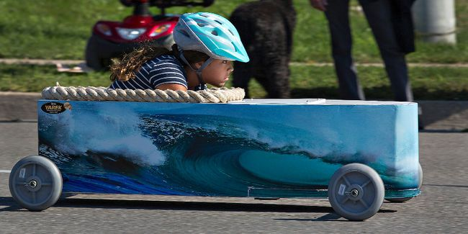

Rules
REGISTRATION: 8AM
RACE START TIME: 9 AM (WEATHER PERMITTING)

All participants must have a parent or guardian present to sign waiver
Must be a resident of Brantford, Brant, Six Nations of the Grand, Haldimand or Norfolk
Driver must be 12 or under on day of race
Only one participant per car per heat, cars may share drivers, but only one participant will be declared if car places
BDLC Race Stewards have final say on all race issues
All participants must wear a helmet with a chin strap
No added weights, ballasts or Professional wheels allowed
Cars that cross the centre line and interfere with the other car will be disqualified
Cars disqualified before the race will be given two runs, but will not be able to place despite the result of their race

